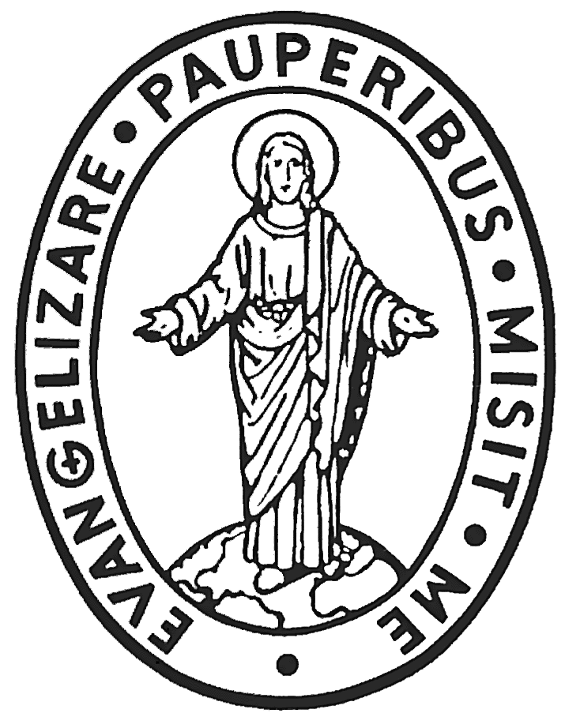
CONGREGAZIONE DELLA MISSIONE

CURIA GENERALIZIA
Via dei Capasso, 30 – 00164 ROMA
Tel: +39 06 661 30 61 – Fax: +39 06 666 38 31 – Email: cmcuria@cmglobal.org

SUPERIORE GENERALE

Rome, 10 April 2017

To the Visitors and Vice-Visitors of the Congregation of the Mission

Dear confreres,

May the grace and peace of Jesus be always with us!

This Jubilee Year of the 400th Anniversary of the Vincentian Charism invites us, in a special way, to give thanks to Jesus for our vocation, for the call to follow Him in the footsteps of our Founder.

Filled with inner fire, we are called in stability, chastity, poverty, obedience, simplicity, humility, meekness, mortification, and zeal to fulfill the mission entrusted to each one of us by Jesus. It comes so naturally that, as we fulfill this mission, it is our hearts’ desire to have new members join us. Jesus’ words, expressed more than 2000 years ago, remain so relevant today: “The harvest is abundant but the laborers are few; so ask the master of the harvest to send out laborers for his harvest” (Matthew 9:37-38). Jesus himself confirms the fact that the mission entrusted to us is enormous and that there are not enough missionaries to carry out the task. At the same time, however, he invites and challenges us to ask for new laborers, new missionaries, and to trust that he can deliver in the fullest sense of the word.

The Final Document of the 42nd General Assembly speaks of our formation and straightforwardly places before us the importance of developing a clear understanding of who we are as members of the Congregation of the Mission and of being equipped with all the tools to fulfill our mission in the best possible way. The General Assembly, as the highest authority in the Congregation of the Mission, made a clear statement that formation in all its stages is for us a source of renewed energy. It is also a way of preparing our members holistically, so that they will grow in knowledge of who a missionary of Saint Vincent de Paul is and of our spirituality and charism, our place in the Church and in the world.
Having in mind the mandate given us by the last General Assembly and the 400th Anniversary of the Vincentian Charism, I would like, in this letter, to touch on three points:

- Initial Formation
- Formation of Formators
- Plans, Strategies, and Initiatives in Pastoral Work for New Vocations

To respond to this mandate, the General Council would like, in the coming six years, to understand better the overall situation in the areas of Initial Formation, Formation of Formators, and Pastoral Work for New Vocations on the level of the whole Congregation.

We would like to collect all the programs on the level of Initial Formation from all the different steps: Candidacy, Internal Seminary, Philosophy, Theology, and Year of Pastoral Placement that are already in place at the provincial, interprovincial, and international levels. In the same way, we would like to put together the different programs and initiatives that are in place on the provincial, interprovincial, and international levels in the area of Formation of Formators. The third point concerns the programs, initiatives, and plans taking place in the area of Pastoral Work for Vocations on the provincial, interprovincial, and international levels.

With this in mind, I ask the Visitors and Vice-Visitors to send the following programs, initiatives, and plans of your province or vice-province to the General Curia (cmcuria@cmglobal.org) no later than 15 May 2017:

- The General Plan for Initial Formation being implemented at the provincial, interprovincial, or international level of which your province or vice-province is a part.
- The General Plan for the Formation of Formators being implemented at the provincial, interprovincial, or international level of which your province or vice-province is a part.
- The General Plan for Pastoral Work for New Vocations being implemented presently at the provincial, interprovincial, or international level of which your province or vice-province is a part.

Speaking of new vocations to the Congregation of the Mission, on a few occasions, I came across the fact that in some provinces, vice-provinces, and international missions there are many potential vocations to the Congregation, but, because of a lack of financial resources, they cannot be invited and accepted to join us. I am convinced that if Jesus is calling those young men in different parts of the world to follow him in our Congregation, we must be open to Providence. Therefore, we will do all in our power to remove the financial obstacles that some are facing in the field of recruitment to the Congregation of the Mission.

I ask the Visitors, Vice-Visitors, and the Superiors of International Missions, who are experiencing financial hardships and are without the resources needed to put in place a pastoral plan for new vocations or have seminaries who cannot accept all the candidates because of lack of funds, to send us information on your present financial situation. Please include your assessment of how to go forward in order to carry out, in an optimal way, the pastoral plan for new vocations, as well as the implementation of the initial formation plan.

Let me thank each of you with all my heart for all your tremendous efforts and initiatives in the three above-mentioned fields that are in place in the Congregation. I would like to emphasize that all of us, who serve in the General Curia, will do everything possible to keep supporting each of you in these so crucial and central ministries of the Congregation of the Mission.

As we turn to Jesus, Our Lady of the Miraculous Medal, Saint Vincent, and all the Blessed and Saints of the Vincentian Family for intercession, it came mind to suggest that we also turn to our deceased confreres to intercede for us and for new vocations. Many of you probably are doing so already with regularity and so much faith. In my letter of 25 January 2017, I asked each of us, as well as all the branches of the Vincentian Family, to invite one new candidate to join us during this Jubilee Year. We definitely have thousands and thousands of confreres in heaven who have joined us already in this campaign or are eager to join us if we ask them.

May the Lenten journey keep bringing us many blessings. May we continue praying for one another.

Your brother in Saint Vincent,

Tomaž Mavrič, CM
Superior General

